Civil war in Sierra Leone

UNSC Resolution: | 1270
Date of adoption: | 22 October 1999
Operative paragraph: | 22
Demand number: | 2

Megan MacKenzie

Wording of demand
ensure safe and unhindered access of humanitarian assistance to those in need in Sierra Leone, guarantee the safety and security of humanitarian personnel and respect strictly the relevant provisions of international humanitarian and human rights law

List of addressees of the demand

Government of Sierra Leone, Armed Forces Revolutionary Council, Civil Defence Forces , Revolutionary United Front

Short-term compliance

Description of the addressee(s)’ conduct

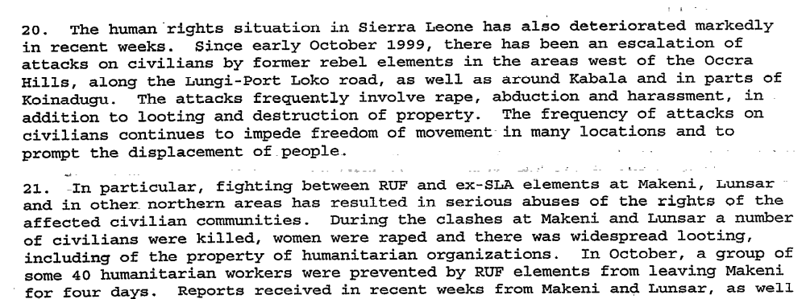

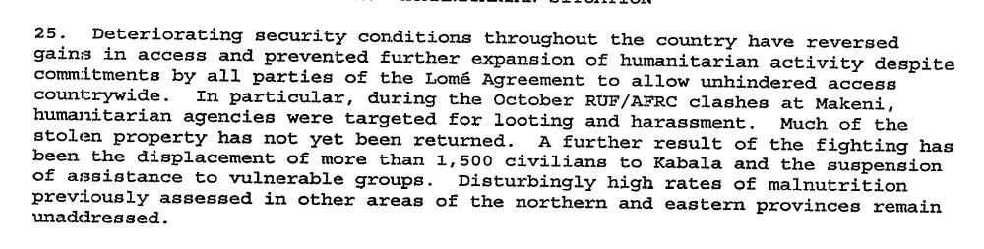

Assessment

Short-term compliance
x No or marginal compliance (1) | Medium low compliance (2) | Medium high compliance (3) | Full or almost full compliance (4)

Considerations underlying the assessment
There is clear indication from the Secretary General’s reports that there were human rights abuses and violations of international law. The reports specify that de to violence and insecurity, humanitarian assistance was hindered.

Medium-term compliance

Description of the addressee(s)’ conduct
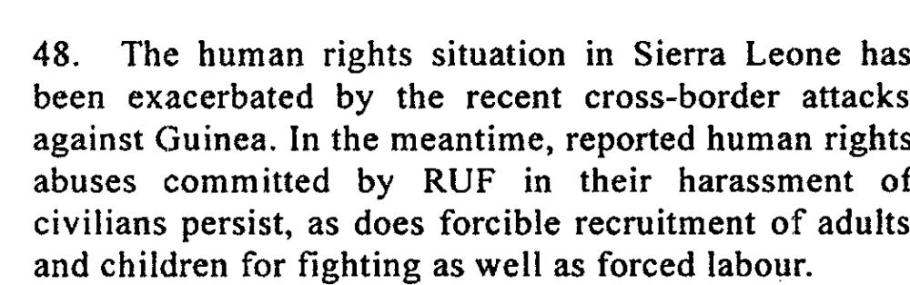
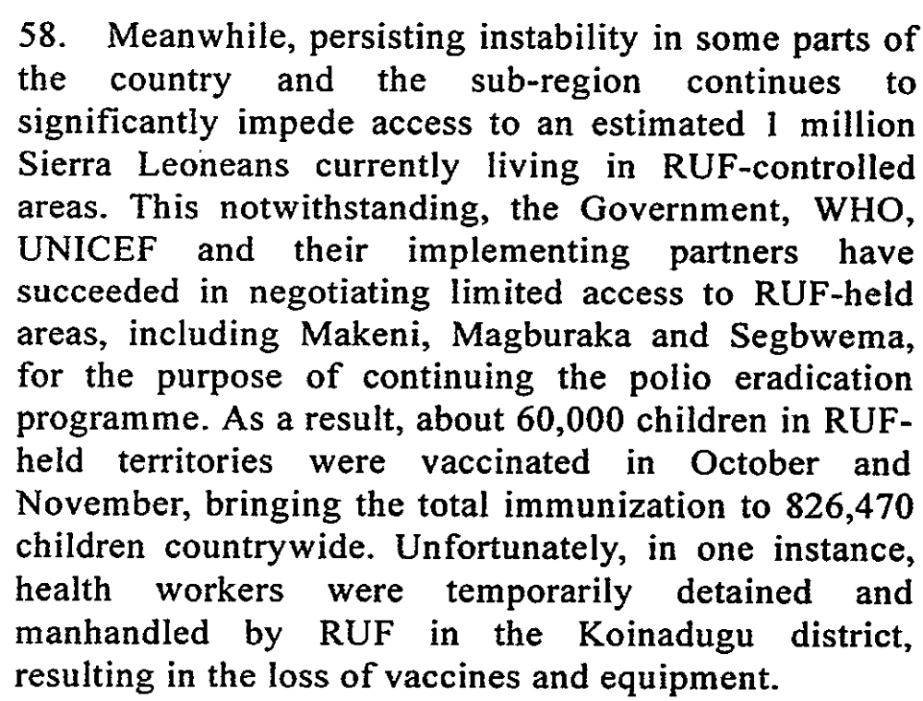

40. Investigations conducted by the Human Rights Section of UNAMSIL during the reporting period revealed attacks against the civilian population by both
RUF and the Civil Defence Forces in several villages in the Kono and Koinadugu districts. On 17 June 2001, a CDF group attacked the village of Yaraiya.
Corroborating witness accounts revealed that 24 people were killed in the attack. Following that incident, RUF combatants attacked the village of Henekuma on 19
July, killing at least 19 people. The RUF leadership attributed this attack to an unauthorized act by a renegade commander, and undertook to apprehend him.

Assessment

Medium-term compliance
x No or marginal compliance (1) | Medium low compliance (2) | Medium high compliance (3) | Full or almost full compliance (4)

Considerations underlying the assessment
There were clear human rights abuses and violations of international law by several of the parties addressed in this demand.

Depth of demand

Assessment

Level of depth of demand
Low depth of demand (1) | Medium depth of demand (2) | x High depth of demand (3)

Considerations underlying the assessment
This was a period characterized by chaos, violence and human rights abuses. By asking the parties to respect human rights and international law as well as facilitating humanitarian access, the UN was demanding that the parties alter their behavior substantially.

Level of confidence about coding decisions

Level of confidence about coding decision
x Extremely high | High | Moderate

Comments to IPI (if any)

Civil war in Sierra Leone

UNSC Resolution: | 1270
Date of adoption: | 22 October 1999
Operative paragraph: | 23
Demand number: | 1

Megan MacKenzie

Wording of demand
expedite the formation of professional and accountable national police and armed forces, including through their restructuring and training, without which it will not be possible to achieve long-term stability, national reconciliation and the reconstruction of the country

List of addressees of the demand

Short-term compliance

Description of the addressee(s)’ conduct

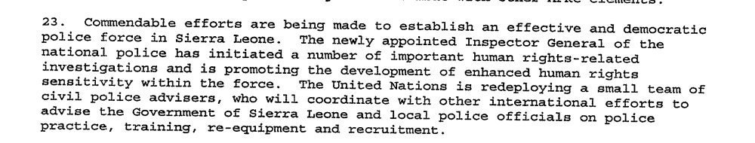

Assessment

Short-term compliance
No or marginal compliance (1) | Medium low compliance (2) | Medium high compliance (3) | x Full or almost full compliance (4)

Considerations underlying the assessment
Within a few months of this demand, it is clear that effort was being made to establish a professional and accountable national police and armed force.

Medium-term compliance

Description of the addressee(s)’ conduct

As of July 2003, the police in particular were finding it difficult to meet the benchmarks of the withdrawal process. They are under-equipped, under-staffed, and under-trained, and their deployment in many parts of the country is in such small numbers as to be more ceremonial than practical.
The Sierra Leone Police (SLP) are the weakest link in the security sector, with shortfalls in personnel, training and resources
There is a general consensus in both the RSLAF and IMATT that reconstruction of the military is not yet complete

Assessment

Medium-term compliance
No or marginal compliance (1) | x Medium low compliance (2) | Medium high compliance (3) | Full or almost full compliance (4)

Considerations underlying the assessment
In the longer term, the national police force was not viewed as a stable and successful entity. The effort to establish the force was commendable, but 2 years later the force was still weak, fractured, and unrealiable.

Depth of demand

Assessment

Level of depth of demand
Low depth of demand (1) | x Medium depth of demand (2) | High depth of demand (3)

Considerations underlying the assessment
Complying with this demand required significant resources and coordination on the part of the Sierra Leone government. Also, because of the security situation and the difficulty recruiting reliable individuals, it was not an easy task to establish a police force and armed force.

Level of confidence about coding decisions

Level of confidence about coding decision
Extremely high | x High | Moderate

Comments to IPI (if any)

Civil war in Sierra Leone

UNSC Resolution: | 1289
Date of adoption: | 7 February 2000
Operative paragraph: | 3
Demand number: | 2

Megan MacKenzie

Wording of demand

fulfil all their commitments under the Peace Agreement to facilitate the restoration of peace, stability, national reconciliation and development in Sierra Leone

List of addressees of the demand

Government of Sierra Leone, Armed Forces Revolutionary Council, Civil Defence Forces , Revolutionary United Front

Short-term compliance

Description of the addressee(s)’ conduct

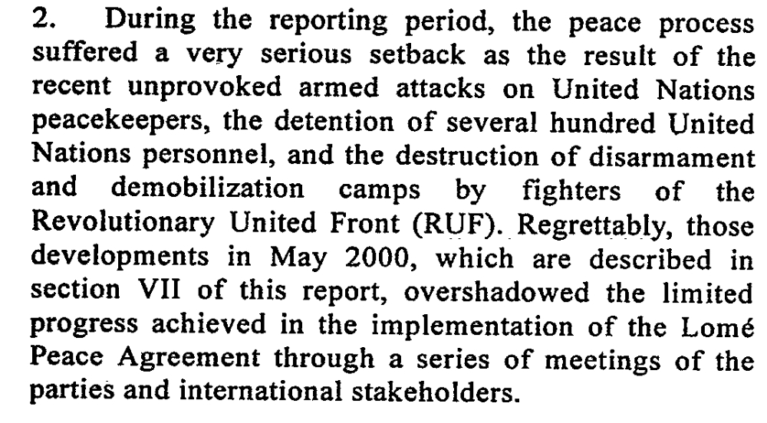
Abidjan’s timetables were not met. Instead, Sierra Leone experienced further turmoil and conflict, demonstrating the country’s rebel factions were not committed to peace.

Assessment

Short-term compliance
x No or marginal compliance (1) | Medium low compliance (2) | Medium high compliance (3) | Full or almost full compliance (4)

Considerations underlying the assessment
There is clear evidence that the Peace Agreement was not adhered to. In fact, UN personnel were kidnapped and hostilities increased during.

Medium-term compliance

Description of the addressee(s)’ conduct
2. The Sierra Leone peace process continued to make encouraging progress during the period under review. The disarmament of combatants of the Revolutionary United Front (RUF) and the Civil Defence Forces (CDF) has so far been completed in four districts, including the diamond-producing Kono district. With the exception of skirmishes between the Civil Defence Forces and RUF which marred the initial stages of the disarmament exercise in Kono district, the ceasefire has generally continued to hold.

Assessment

Medium-term compliance
No or marginal compliance (1) | Medium low compliance (2) | x Medium high compliance (3) | Full or almost full compliance (4)

Considerations underlying the assessment
Within this longer period there was still hostilities; however, the kidnapped UN personnel were released and there is evidence that the parties were committed to the restoration of peace, stability, national reconciliation and development in the country- key elements of the demand.

Depth of demand

Assessment

Level of depth of demand
Low depth of demand (1) | Medium depth of demand (2) | x High depth of demand (3)

Considerations underlying the assessment
Each of the sub-demands within this demand require substantial attention and commitment. Parties were expected to comply with the detailed Peace Agreement as well as facilitate the restoration of peace, stability, national reconciliation and development in Sierra Leone.

Level of confidence about coding decisions

Level of confidence about coding decision
Extremely high | x High | Moderate

Comments to IPI (if any)

Civil war in Sierra Leone

UNSC Resolution: | 1289
Date of adoption: | 7 February 2000
Operative paragraph: | 6
Demand number: | 1

Megan MacKenzie

Wording of demand

take steps to ensure that the disarmament, demobilization and reintegration programme is fully implemented throughout the country

List of addressees of the demand

Government of Sierra Leone, Armed Forces Revolutionary Council, Civil Defence Forces , Revolutionary United Front

Short-term compliance

Description of the addressee(s)’ conduct

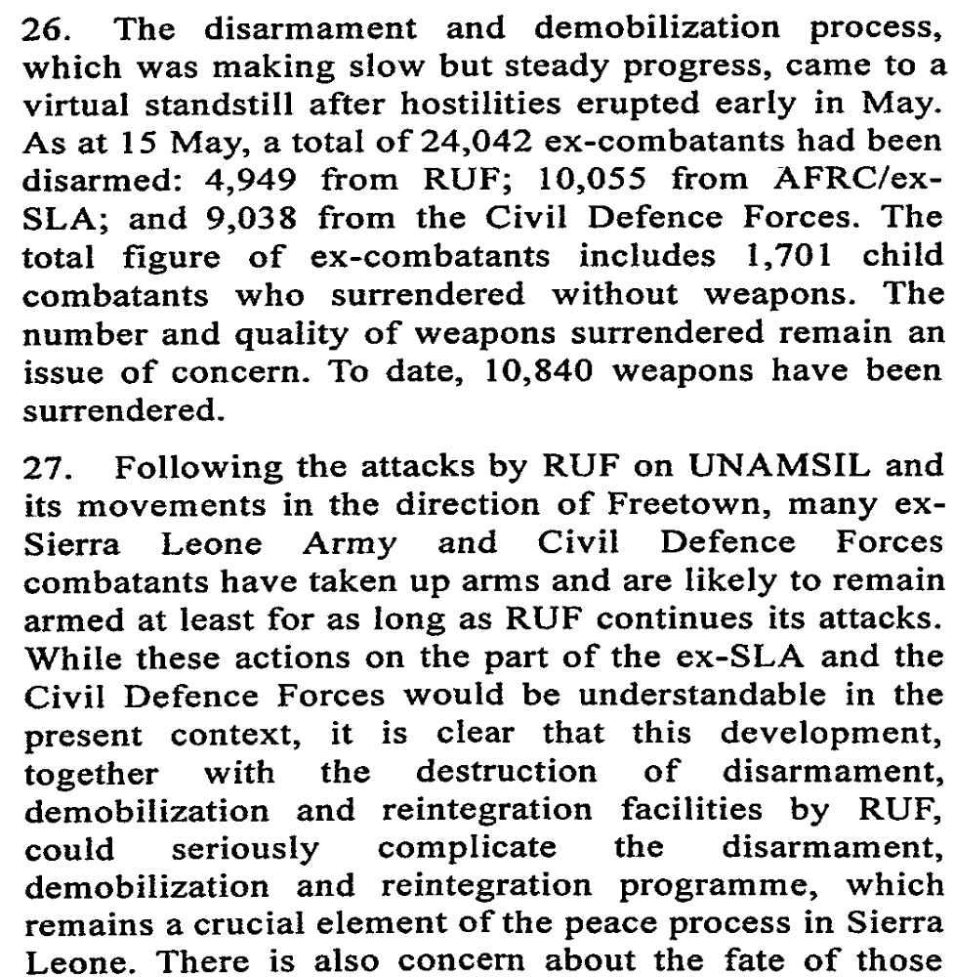

Assessment

Short-term compliance
x No or marginal compliance (1) | Medium low compliance (2) | Medium high compliance (3) | Full or almost full compliance (4)

Considerations underlying the assessment
The demand asks that the program be fully implemented, yet research shows that the program had to be halted due to rebel activity.

Medium-term compliance

Description of the addressee(s)’ conduct

21. As indicated above, the disarmament, demobilization and reintegration process has made remarkable progress. Since the programme resumed on 18 May, a total of 16,097 (6,523 RUF, 9,399 CDF and 175 AFRC/ex-Sierra Leone Army) combatants had been disarmed as at 3 September, out of an estimated 25,000. A total of 6,502 weapons and 728,058 assorted pieces of ammunition have so far been collected.

Referring to DDR- ‘the program’s scope and procedural mechanisms were vague. Little guidance was available to implementers….the necessary implementation funds…were never raised.

November 10, 2000, the government and the RUF concluded the Abuja Cease-Fire Agreement (Abuja I). They reaffirmed their commitment to Lome and to Unamsil’s central role in overseeing the ceasefire, promised it unimpeded access through the country, and pledged to participate in the disarmament and demobilization programs.

Assessment

Medium-term compliance
No or marginal compliance (1) | Medium low compliance (2) | Medium high compliance (3) | x Full or almost full compliance (4)

Considerations underlying the assessment
Over the long term the disarmament process was implemented in a way that could be called “fully.” There has been some criticism about the number of participants in the program and the lack of resources; however this demand is primarily concerned with implementation.

Depth of demand

Assessment

Level of depth of demand
Low depth of demand (1) | Medium depth of demand (2) | x High depth of demand (3)

Considerations underlying the assessment
Asking these parties to ensure the disarmament programme is fully implemented implies allowing unhindered access of the UN and Government to areas formerly controlled by rebel forces. In addition, disarming the fighting factions was a huge threat to their existence and legitimacy as a group.

Level of confidence about coding decisions

Level of confidence about coding decision
Extremely high | x High | Moderate

Comments to IPI (if any)

Civil war in Sierra Leone

UNSC Resolution: | 1289
Date of adoption: | 7 February 2000
Operative paragraph: | 6
Demand number: | 1

Megan MacKenzie

Wording of demand

participate fully in the programme and cooperate with all those responsible for its implementation

List of addressees of the demand

Government of Sierra Leone, Armed Forces Revolutionary Council, Civil Defence Forces , Revolutionary United Front

Short-term compliance

Description of the addressee(s)’ conduct

Assessment

Short-term compliance
x No or marginal compliance (1) | Medium low compliance (2) | Medium high compliance (3) | Full or almost full compliance (4)

Considerations underlying the assessment
During this time parties were not able to participate in the disarmament process primarily because of the activities of the RUF.

Medium-term compliance

Description of the addressee(s)’ conduct

21. As indicated above, the disarmament, demobilization and reintegration process has made remarkable progress. Since the programme resumed on 18 May, a total of 16,097 (6,523 RUF, 9,399 CDF and 175 AFRC/ex-Sierra Leone Army) combatants had been disarmed as at 3 September, out of an estimated 25,000. A total of 6,502 weapons and 728,058 assorted pieces of ammunition have so far been collected.

Assessment

Medium-term compliance
No or marginal compliance (1) | Medium low compliance (2) | x Medium high compliance (3) | Full or almost full compliance (4)

Considerations underlying the assessment
It is clear that the parties to this demand made a sincere effort to comply. High numbers of the fighting factions had already disarmed within this period, yet there was still some concern about the low number of RUF/AFRC participation.

Depth of demand

Assessment

Level of depth of demand
Low depth of demand (1) | Medium depth of demand (2) | x High depth of demand (3)

Considerations underlying the assessment
Participating in the disarmament and demobilization process changed the dynamics and the very existence of some of the parties to the demand. For years, the parties to the demand had used weapons to hold power and attain their objectives. Giving up these weapons and demobilizing represented a drastic change in their behavior. x

Level of confidence about coding decisions

Level of confidence about coding decision
Extremely high | High | Moderate

Comments to IPI (if any)

Civil war in Sierra Leone

UNSC Resolution: | 1289
Date of adoption: | 7 February 2000
Operative paragraph: | 15
Demand number: | 3?

Megan MacKenzie

Wording of demand

respect fully the status of United Nations and associated personnel

List of addressees of the demand

Government of Sierra Leone, Armed Forces Revolutionary Council, Civil Defence Forces , Revolutionary United Front

Short-term compliance

Description of the addressee(s)’ conduct

The Lomé agreement collapsed in May 2000. The RUF was chiefly to blame, sabotaging the peace process by capturing 500 UN peacekeepers and their equipment.

May 2000 RUF rebels took over 400 UN peacekeepers hostage.

Assessment

Short-term compliance
x No or marginal compliance (1) | Medium low compliance (2) | Medium high compliance (3) | Full or almost full compliance (4)

Considerations underlying the assessment
There is no grey area with this demand. Rebels certainly disrespected the status of UN personnel when they kidnapped them and held them hostage.

Medium-term compliance

Description of the addressee(s)’ conduct

In May 2000, the Lomé peace agreement granted the rebels incentives that included a full amnesty, legalised control of diamond resources and senior positions in the government, yet the RUF killed several peacekeepers and marched towards
Freetown because some minor demands had not been met. P8
FREETOWN, Sierra Leone (AP) -- One Indian U.N. peacekeeper was killed and seven peacekeepers were injured during the weekend raid to free more than 200 U.N. soldiers who were surrounded by rebels, the U.N. commander in Sierra Leone said Monday.

7. However, RUF has yet to return all the weapons and equipment seized from UNAMSIL and the Monitoring Group (ECOMOG) of the Economic Community of West African States (ECOWAS); no further items have been returned since the issuance of my last report. While the RUF leadership had indicated

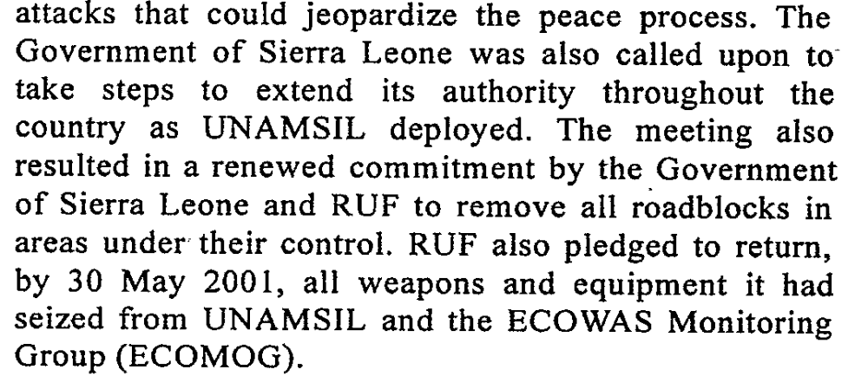

Assessment

Medium-term compliance
x No or marginal compliance (1) | Medium low compliance (2) | Medium high compliance (3) | Full or almost full compliance (4)

Considerations underlying the assessment
The situation in the country improved over the course of this period; however, UN staff were also threatened and injured during this time. RUF also withheld some of the equipment it had stolen.

Depth of demand

Assessment

Level of depth of demand
Low depth of demand (1) | x Medium depth of demand (2) | High depth of demand (3)

Considerations underlying the assessment
Respecting the mission required that the rebels give up a certain amount of power in terms of access to territory. In addition, it required the parties to alter their behavior at least to the extent that it ensured the safety and integrity of the UN mission and its staff.

Level of confidence about coding decisions

Level of confidence about coding decision
x Extremely high | High | Moderate

Comments to IPI (if any)

Civil war in Sierra Leone

UNSC Resolution: | 1289
Date of adoption: | 7 February 2000
Operative paragraph: | 16
Demand number: | 2

Megan MacKenzie

Wording of demand

conclude a status-of-forces agreement with the Secreatary-General within 30 days of the adoption of this resolution

List of addressees of the demand

Government of Sierra Leone

Short-term compliance

Description of the addressee(s)’ conduct

Assessment

Short-term compliance
No or marginal compliance (1) | Medium low compliance (2) | Medium high compliance (3) | Full or almost full compliance (4)

Considerations underlying the assessment

Medium-term compliance

Description of the addressee(s)’ conduct

Assessment

Medium-term compliance
No or marginal compliance (1) | Medium low compliance (2) | Medium high compliance (3) | Full or almost full compliance (4)

Considerations underlying the assessment

Depth of demand

Assessment

Level of depth of demand
Low depth of demand (1) | Medium depth of demand (2) | High depth of demand (3)

Considerations underlying the assessment

Level of confidence about coding decisions

Level of confidence about coding decision
Extremely high | High | Moderate

Comments to IPI (if any)
* I could not find any research related to a status of forces agreement. I could not assess this demand.

Civil war in Sierra Leone

UNSC Resolution: | 1289
Date of adoption: | 7 February 2000
Operative paragraph: | 17
Demand number: | 2

Megan MacKenzie

Wording of demand

promote peace and national reconciliation and foster accountability and respect for human rights in Sierra Leone, and accelerate their efforts to establish the Truth and Reconciliation Commission, the Human Rights Commission and the Commission for the Consolidation of Peace as fully-functioning and effective institutions, as provided for under the Peace Agreement

List of addressees of the demand

Government of Sierra Leone

Short-term compliance

Description of the addressee(s)’ conduct
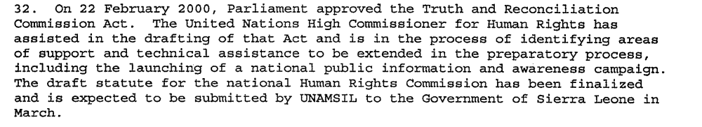

Assessment

Short-term compliance
No or marginal compliance (1) | Medium low compliance (2) | Medium high compliance (3) | x Full or almost full compliance (4)

Considerations underlying the assessment
The Government of Sierra Leone showed a clear and timely response to this demand. Efforts were made almost immediately after this demand was issued to establish a TRC and a Human Rights Commission.

Medium-term compliance

Description of the addressee(s)’ conduct

After a troubled start at the end of 2002, the TRC appears to be on a solid footing.92 Statement-takers have collected many statements from both victims and perpetrators. A new executive secretary, Franklyn Kargbo, and much of the permanent secretariat staff were on board by the end of February 2003.93 Public hearings began in Freetown on 14 April,
continued throughout the country and concluded on 5 August. A TRC representative expressed confidence that given adequate funds the Commissioners will meet the original deadline of October 2003 for submitting a final report. p11

Since January 2002 when President Ahmed Tejan Kabbah officially declared Sierra Leone’s brutal eleven year civil war over, numerous efforts have been made to consolidate the peace. The 14 May election in which the Revolutionary United Front (RUF) rebel group participated and was politically defeated, was, even if flawed, a significant step forward. p1
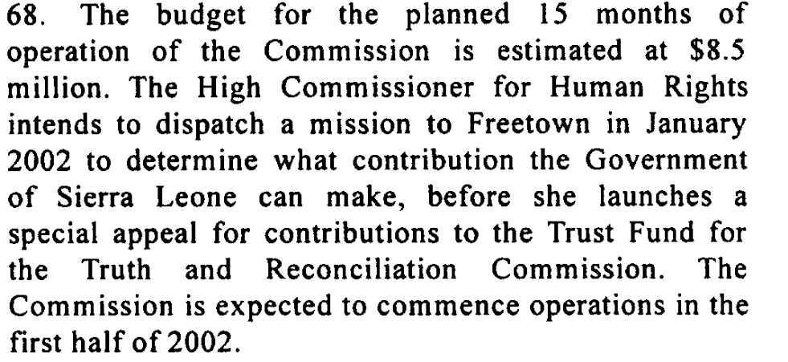

Assessment

Medium-term compliance
No or marginal compliance (1) | x Medium low compliance (2) | Medium high compliance (3) | Full or almost full compliance (4)

Considerations underlying the assessment
The demand specifically asks for the Government to “accelerate” their efforts in establishing these commissions yet budgetary and political constraints slowed this process. The TRC was not fully operational until 2002 and the Human Rights

Depth of demand

Assessment

Level of depth of demand
Low depth of demand (1) | x Medium depth of demand (2) | High depth of demand (3)

Considerations underlying the assessment
In some ways promoting reconciliation through these commissions was in the interests of the Government; therefore it was not a high depth demand. However, establishing these bodies required substantial organization, expertise, and resources.

Level of confidence about coding decisions

Level of confidence about coding decision
x Extremely high | High | Moderate

Comments to IPI (if any)

Civil war in Sierra Leone

UNSC Resolution: | 1289
Date of adoption: | 7 February 2000
Operative paragraph: | 18
Demand number: | 1

Megan MacKenzie

Wording of demand

early and effective operation of the Commission of the Management of Strategic Resources, National Reconstruction and Development

List of addressees of the demand

Government of Sierra Leone

Short-term compliance

Description of the addressee(s)’ conduct

Under the Lomé peace agreement, RUF Leader Sankoh was made chairman of a Commission for the Management of Strategic Resources, National Reconstruction and Development. Until his flight and capture in May, Sankoh apparently used that role to attempt to strike private diamond deals. In part, the Commission was to ensure transparency and accountability in the exploitation of resources and that the proceeds were used for reconstruction and development, particularly in rural areas.

Reports from the northern town of Makeni and the mining areas in the east suggest that the RUF rebels are already behaving like stationary bandits: tax payments by traders to RUF officials are reckoned to be about Le 1,200,000 a day (Concord Times, 1.6.2000) ; and rural folks in mining areas are reported to be providing free labour to RUF diamond
mines on weekends while they are allowed use of their labour for selfprovisioning
on weekdays. Decline in violence is not the same as absence of arbitrariness and occasional lawlessness.

Assessment

Short-term compliance
No or marginal compliance (1) | x Medium low compliance (2) | Medium high compliance (3) | Full or almost full compliance (4)

Considerations underlying the assessment
The demand asks for the “early and effective” operation of this Commission. The Commission was established but there is evidence that it was not effective at all.

Medium-term compliance

Description of the addressee(s)’ conduct
Under the terms of the 1999 Lomé Peace Agreement the RUF leader, Foday Sankoh, received the dual post of vice-president and chairman of the Commission on the Management of Strategic Resources. During the year that the coalition government held, the appointment proved a failure. Sankoh was either incapable or unwilling to enforce the agreement within the RUF and, while banning all mining activities, allowed mining to continue in RUF-controlled areas.19 The RUF was finally neutralized through military intervention by British and Guinean troops in the summer of 2000.
The RUF was also affected by the UN sanctions of 2000 on diamond exports

Assessment

Medium-term compliance
x No or marginal compliance (1) | Medium low compliance (2) | Medium high compliance (3) | Full or almost full compliance (4)

Considerations underlying the assessment
Over the long term, this Commission was widely recognized as a failure and a means of profiteering for the RUF.

Depth of demand

Assessment

Level of depth of demand
Low depth of demand (1) | x Medium depth of demand (2) | High depth of demand (3)

Considerations underlying the assessment
Establishing the Commission required some effort on the part of the parties while the achieving effectiveness for the Commission was a more arduous task. Effectiveness likely implies accountability and transparency and, in particular, required that the RUF hand over diamond resources to the state.

Level of confidence about coding decisions

Level of confidence about coding decision
Extremely high | x High | Moderate

Comments to IPI (if any)

Civil war in Sierra Leone

UNSC Resolution: | 1289
Date of adoption: | 7 February 2000
Operative paragraph: | 20
Demand number: | 2

Megan MacKenzie

Wording of demand

take urgent steps towards the establishment of professional and accountable national police and armed forces

List of addressees of the demand

Government of Sierra Leone

Short-term compliance

Description of the addressee(s)’ conduct

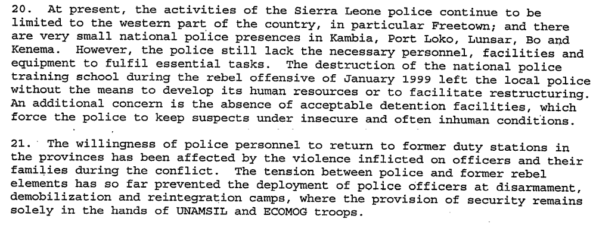
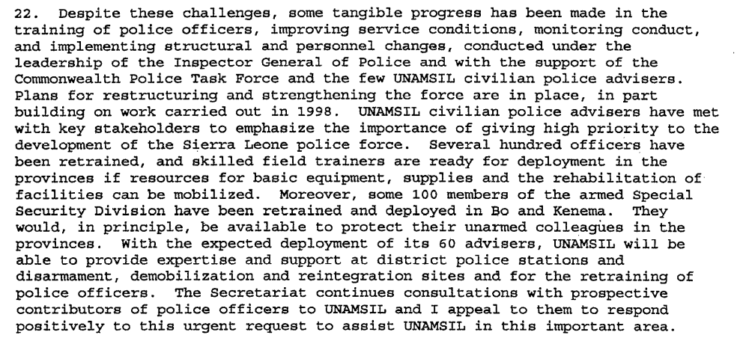

Assessment

Short-term compliance
No or marginal compliance (1) | Medium low compliance (2) | x Medium high compliance (3) | Full or almost full compliance (4)

Considerations underlying the assessment
There were some clear challenges to the establishment of an effective police force but the demand asks the Government to “take urgent steps toward the establishment” of the force and it is clear they made an attempt to do so. Over the short term, it is difficult to determine if the forces are professional and accountable.

Medium-term compliance

Description of the addressee(s)’ conduct

p5 As of July 2003, the police in particular were finding it difficult to meet the benchmarks
of the withdrawal process. They are under-equipped, under-staffed, and under-trained, and their deployment in many parts of the country is in such small numbers as to be more ceremonial than practical. The military (RSLAF) is faring better [than the police], even though it is also short on equipment, housing and training. Its performance in response to border incursions occasioned by the Liberian civil war has been erratic and at times unreliable.

The Sierra Leone Police (SLP) are the weakest link in the security sector, with shortfalls in personnel, training and resources.p8

Assessment

Medium-term compliance
No or marginal compliance (1) | x Medium low compliance (2) | Medium high compliance (3) | Full or almost full compliance (4)

Considerations underlying the assessment
The police force was established and progress was made towards complying with this demand but there is clear evidence that the forces were not fully professionalized or accountable.

Depth of demand

Assessment

Level of depth of demand
Low depth of demand (1) | x Medium depth of demand (2) | High depth of demand (3)

Considerations underlying the assessment
The demand was not a high depth demand because it was in the interests of the Government of Sierra Leone to establish a professional and accountable police force. It was a medium depth demand because complying with this demand required targeted resources, expertise and coordination with international experts.

Level of confidence about coding decisions

Level of confidence about coding decision
Extremely high | x High | Moderate

Comments to IPI (if any)

First Report of the Secretary General on the United Nations Mission in Sierra Leone (UNAMSIL) (S/1999/1223) , 06/12/1999.
Eighth Report of the Secretary-General on UNAMSIL, (S/2000/1199), 15/12/00.
Eleventh Report of the Secretary-General on UNAMSIL, S/2001/857), 07/09/01.
First Report of The Secretary-General on UNAMSIL, (S/1999/1223), 06/12/1999.
International Crisis Group. Sierra Leone: The State of Security and Governance. ICG Africa Report No 67. Freetown/London/Brussels. 3 September 2003. P5.
International Crisis Group. Sierra Leone: The State of Security and Governance. ICG Africa Report No 67. Freetown/London/Brussels. 3 September 2003. P8
International Crisis Group. Sierra Leone: The State of Security and Governance. ICG Africa Report No 67. Freetown/London/Brussels. 3 September 2003. P7
Fourth Report of the Secretary-General on UNAMSIL, (S/2000/455), 19/05/2000.
Eric G. Berman and Melissa T. Labonte, “Sierra Leone” in William J. Durch ed. Sierra Leone 21st Century Peace Operations. (Washington: United States Institute of Peace) p147
Eleventh Report of the Secretary General on UNAMSIL, (S/2001/857), 07/09/2001.
Fourth Report of the Secretary –General on UNAMSIL, (S/2000/455), 19/05/2000.
Eleventh Report of the Secretary-General on UNAMSIL, (S/2001/857), 07/09/2001.
Eric G. Berman and Melissa T. Labonte, “Sierra Leone” in William J. Durch ed. Sierra Leone 21st Century Peace Operations. (Washington: United States Institute of Peace)p158.
Eric G. Berman and Melissa T. Labonte, “Sierra Leone” in William J. Durch ed. Sierra Leone 21st Century Peace Operations. (Washington: United States Institute of Peace) p161.
Fourth Report of the Secretary-General on UNAMSIL, (S/200/455), 19/05/2000.
Eleventh Report of the Secretary-General on UNAMSIL, (S/2001/857), 07/09/2001.
SIERRA LEONE: TIME FOR A NEW MILITARY AND POLITICAL STRATEGY, ICG Africa Report N° 28, Freetown/London/Brussels, 11/04/2001, p3
Eric G. Berman and Melissa T. Labonte, “Sierra Leone” in William J. Durch ed. Sierra Leone 21st Century Peace Operations. (Washington: United States Institute of Peace) p141.
SIERRA LEONE: MANAGING UNCERTAINTY, Africa Report N°35, Freetown/Brussels, 24/12/2001
Associated Press Online, One Indian U.N. Peacekeeper Killed, 17/07/2000.
Eleventh Report of the Secretary-General on UNAMSIL, (S/2001/857), 07/09/2001
Tenth Report of the Secretary-General on UNAMSIL, (S/2001/627), 25/06/2001.
ICG SIERRA LEONE: THE STATE OF SECURITY AND GOVERNANCE, ICG Africa Report N°67, Freetown/BrusselsICG Africa Report N°67, 02/09/03.
AFRICA Briefing, Freetown/Brussels, SIERRA LEONE’S TRUTH AND RECONCILIATION COMMISSION: A FRESH START?, 20/12/2002.
Twelfth Report of the Secretary-General on UNAMSIL, (S/2001/1195), 13/12/2001.
Partnership Africa Canada. “Sierra Leone One Year After the Peace Accord.” AFROL http://www.afrol.com/Countries/Sierra_Leone/backgr_peace_conference.htm
Yusuf Bangura. Strategic policy failure and governance in Sierra Leone The Journal of Modern African Studies (2000), 38 : 551-577 Cambridge University Press Copyright © 2000 Cambridge University Press.
Rubie De-Koning.. Resource-Conflict Links in Sierra Leone and the Democratic Republic of Congo. SIPRI Insights on Peace and Security. October 2008. http://books.sipri.org/files/insight/SIPRIInsight0802.pdf
Third Report of the Secretary-General: covering developments since the second report on UNAMSIL and containing a section describing objectives of the peace process, (S/2000/186), 07/03/2000.
ICG SIERRA LEONE: THE STATE OF SECURITY AND GOVERNANCE, ICG Africa Report N°67, Freetown/BrusselsICG Africa Report N°67, 02/09/2003.
ICG SIERRA LEONE:THE STATE OF SECURITY AND GOVERNANCE, ICG Africa Report N°67, Freetown/BrusselsICG Africa Report N°67, 02/09/2003.

